**Case Study: Performance Monitoring and Analysis with JMeter, Prometheus, and Grafana**

**Site:** Casekaro.com

**Created Test plan**

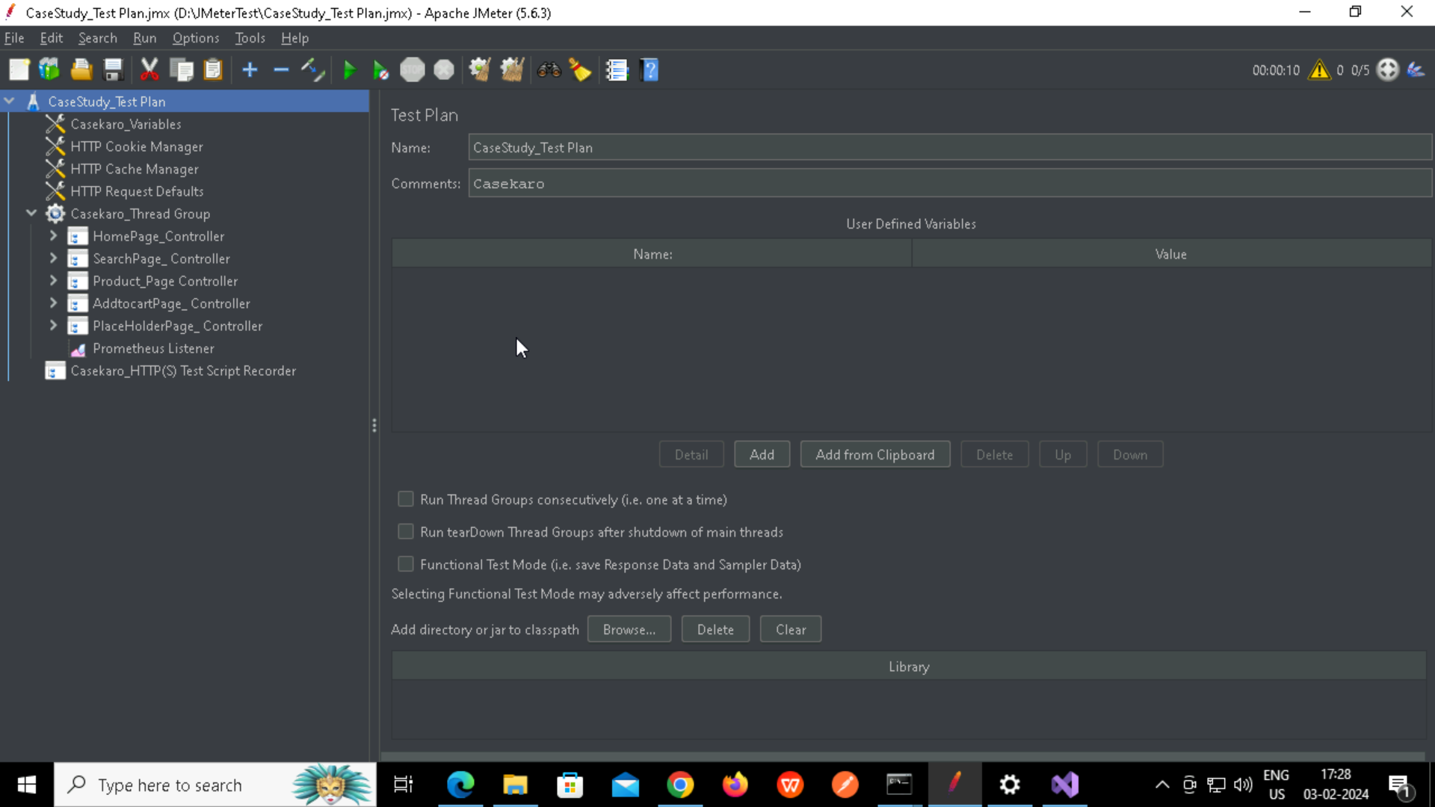

**Created User Defined Variables**

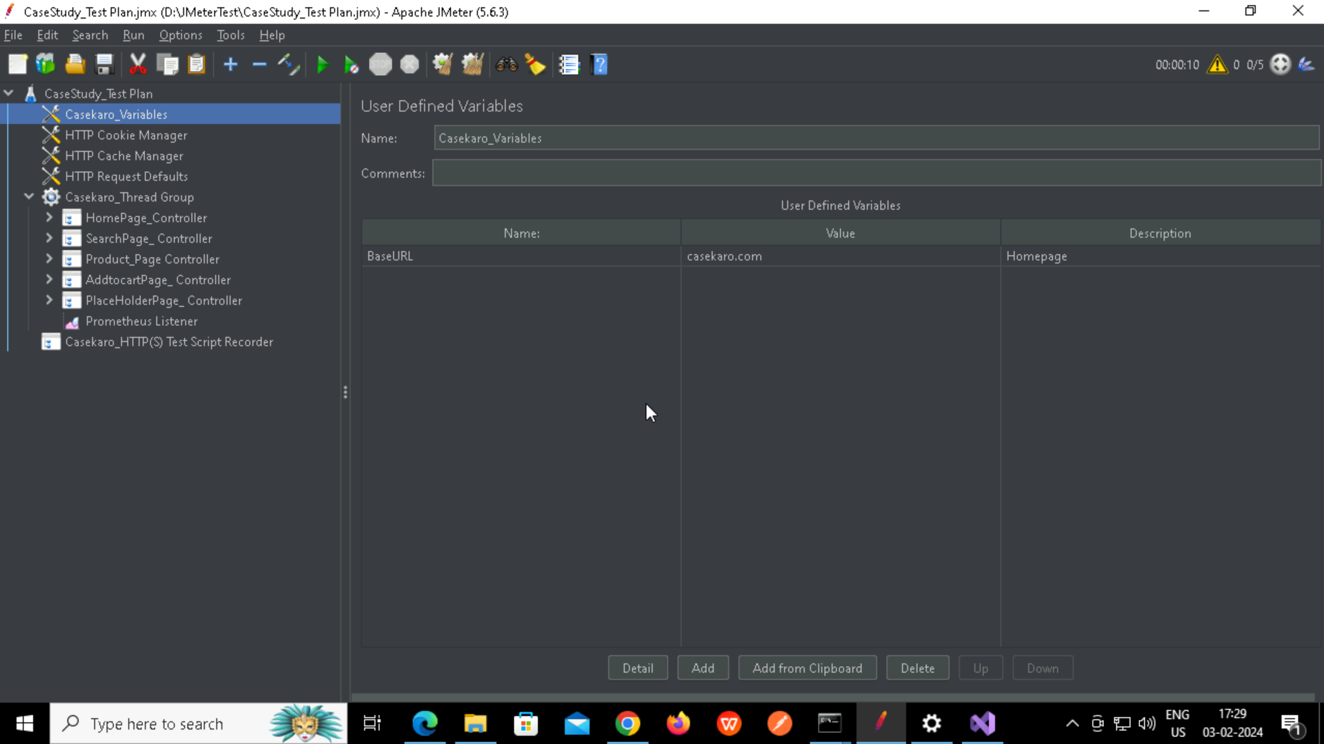

Cookie Manager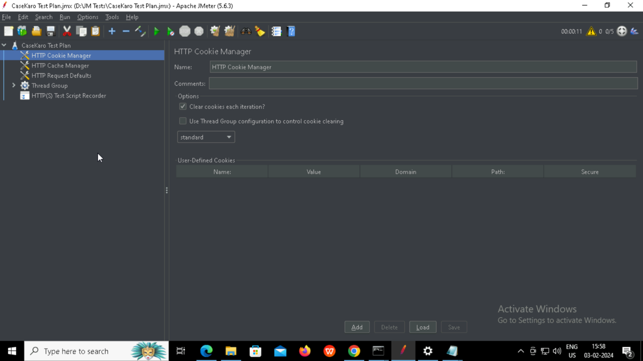

Cache Manager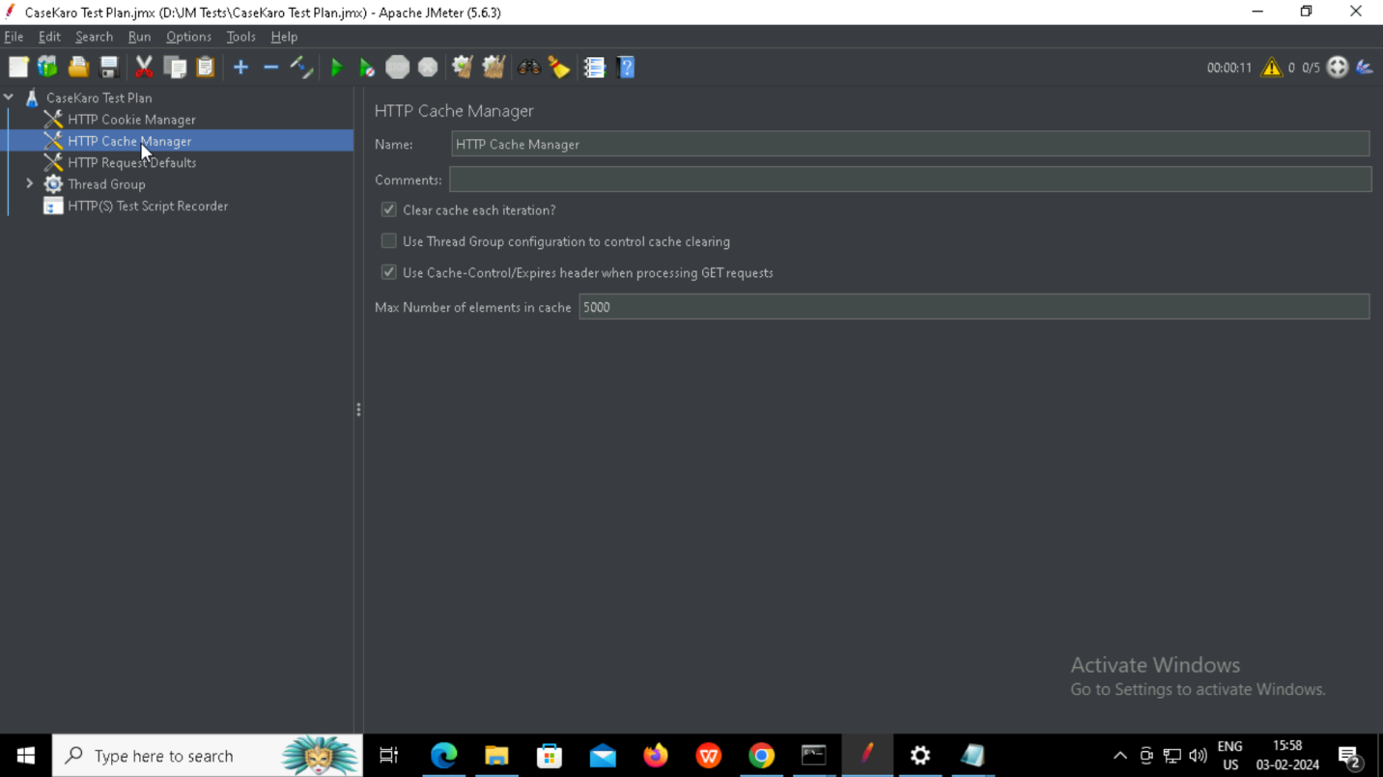

**Request Defaults**

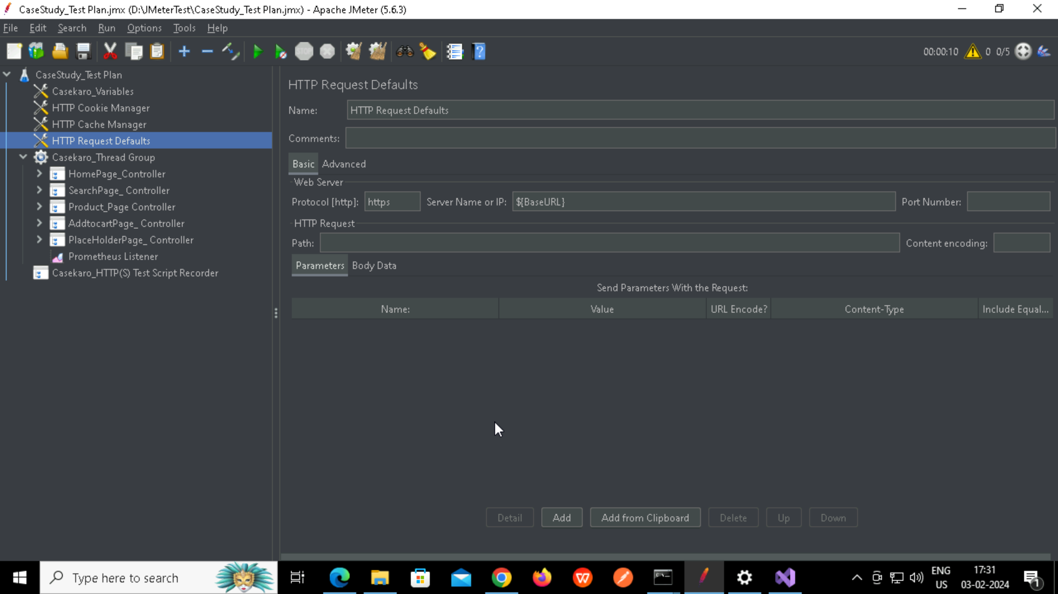

**Test script recorder – Test plan creation**

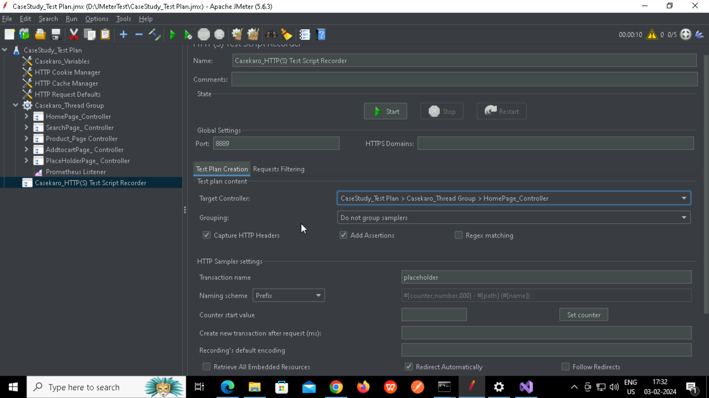

**Filtering requests**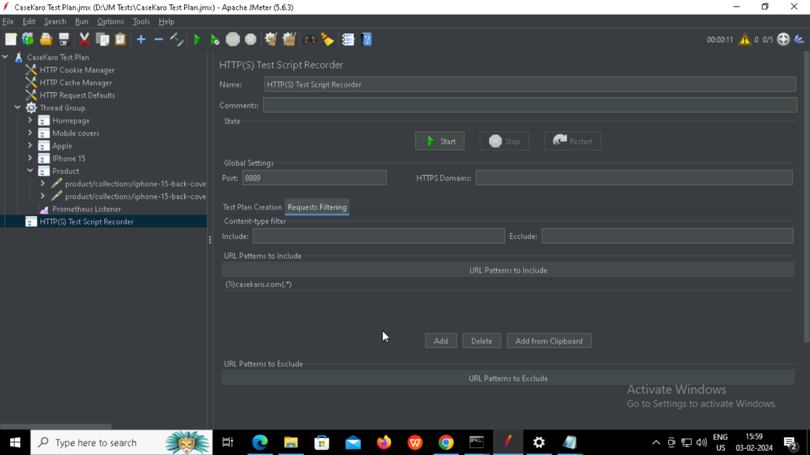

**Creating rules in YAML file**

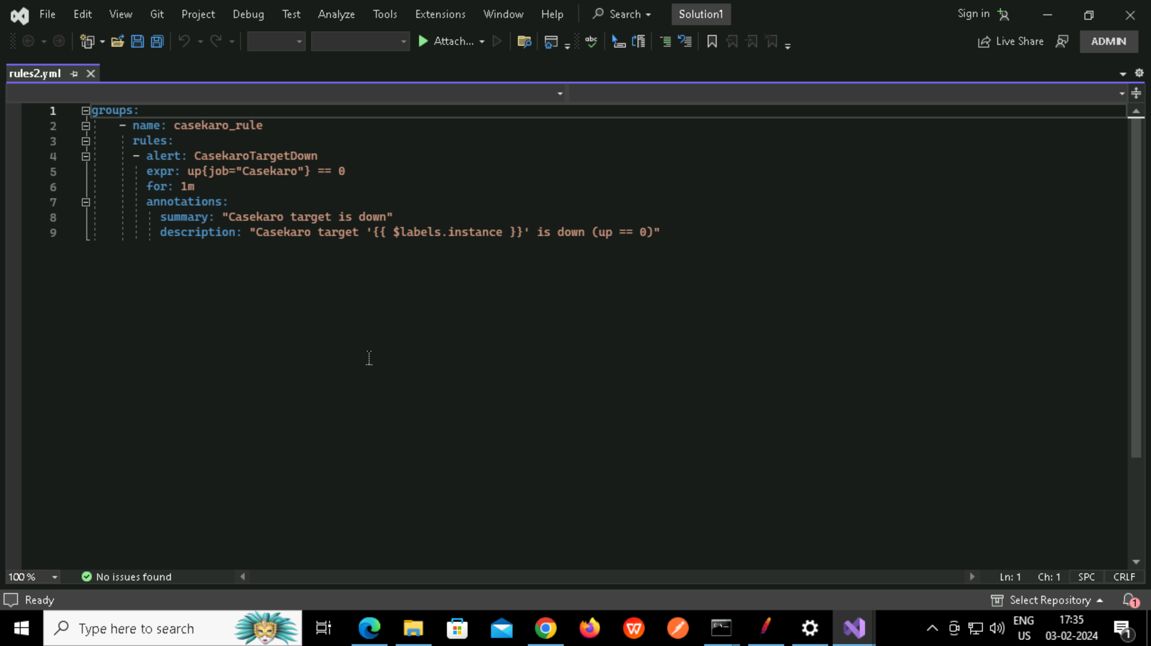

**Configuring prometheus YAML file with new ruleSetting target as localhost:9210**

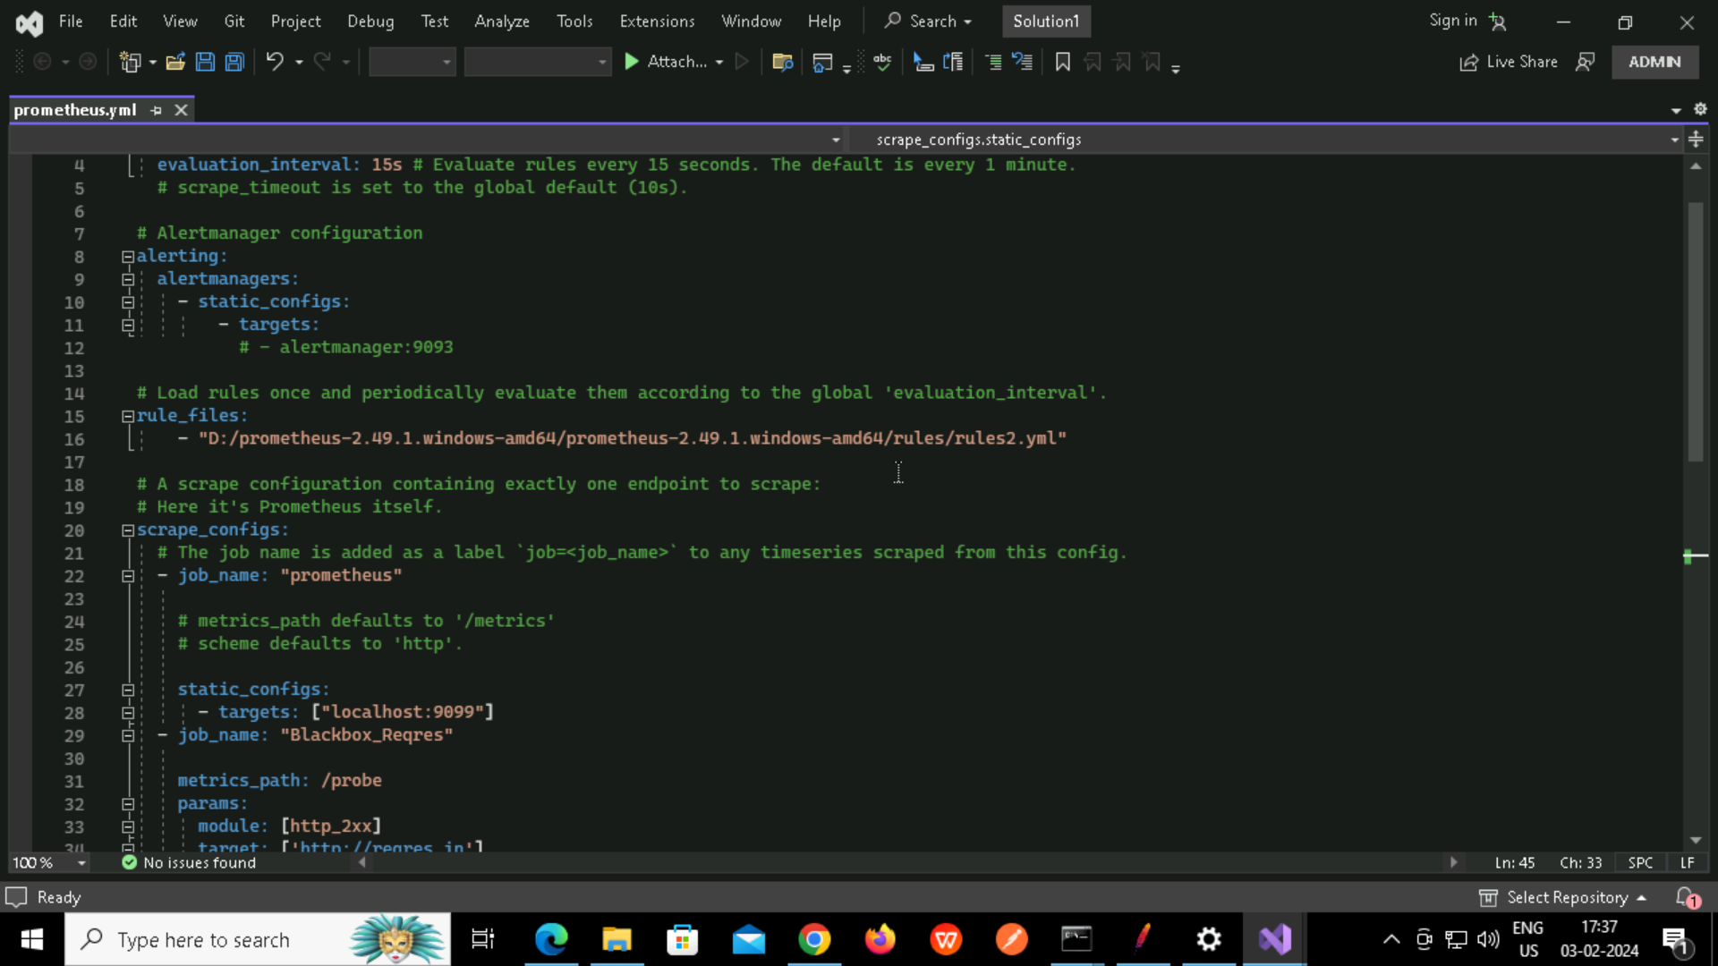

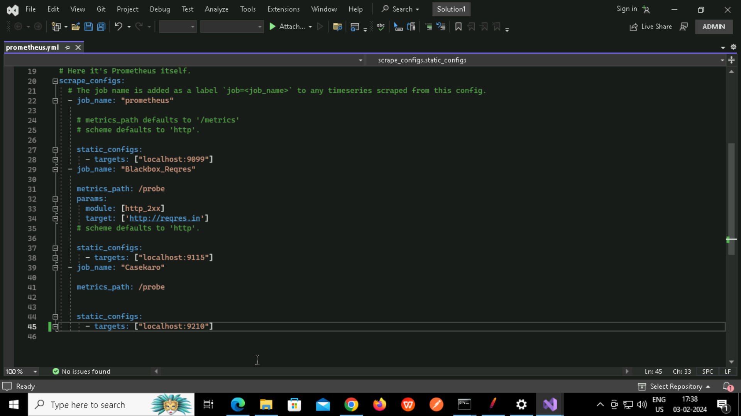

**Metrics in the target**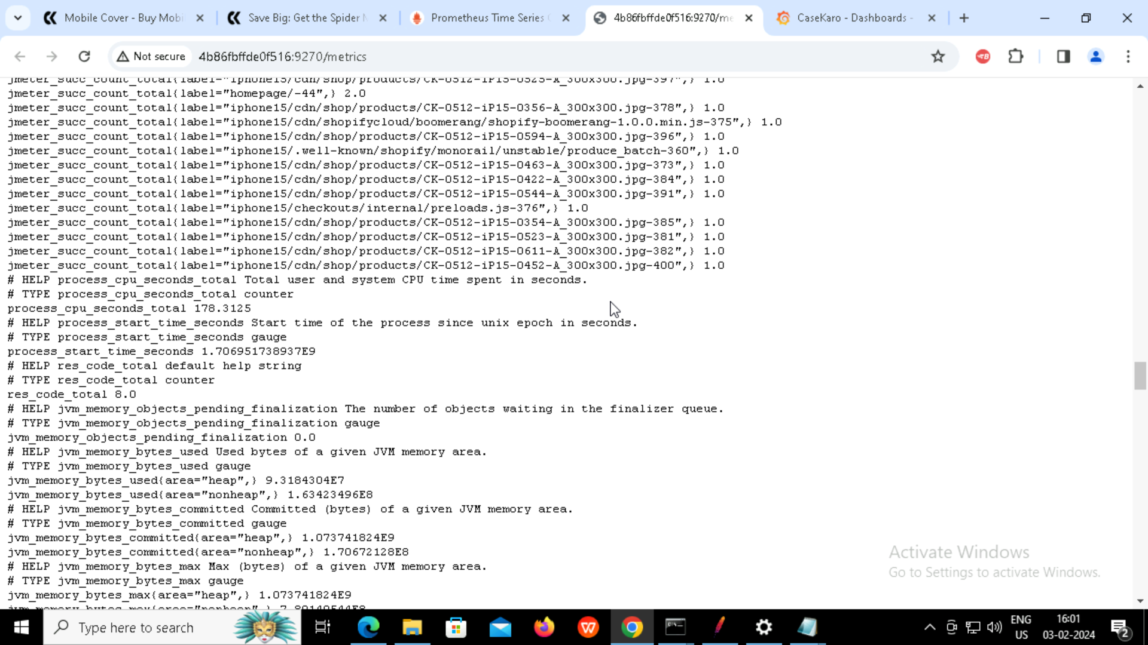

**Alert fired in prometheus**

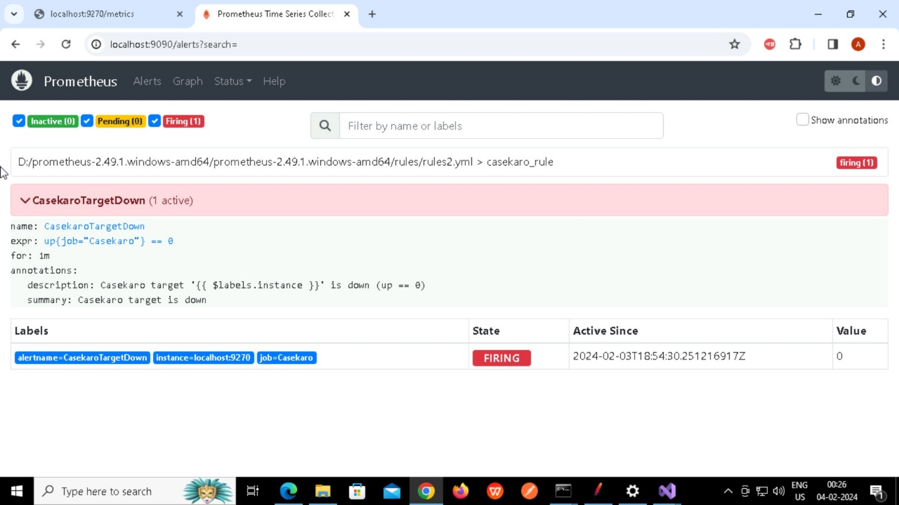

**Final dashboard**

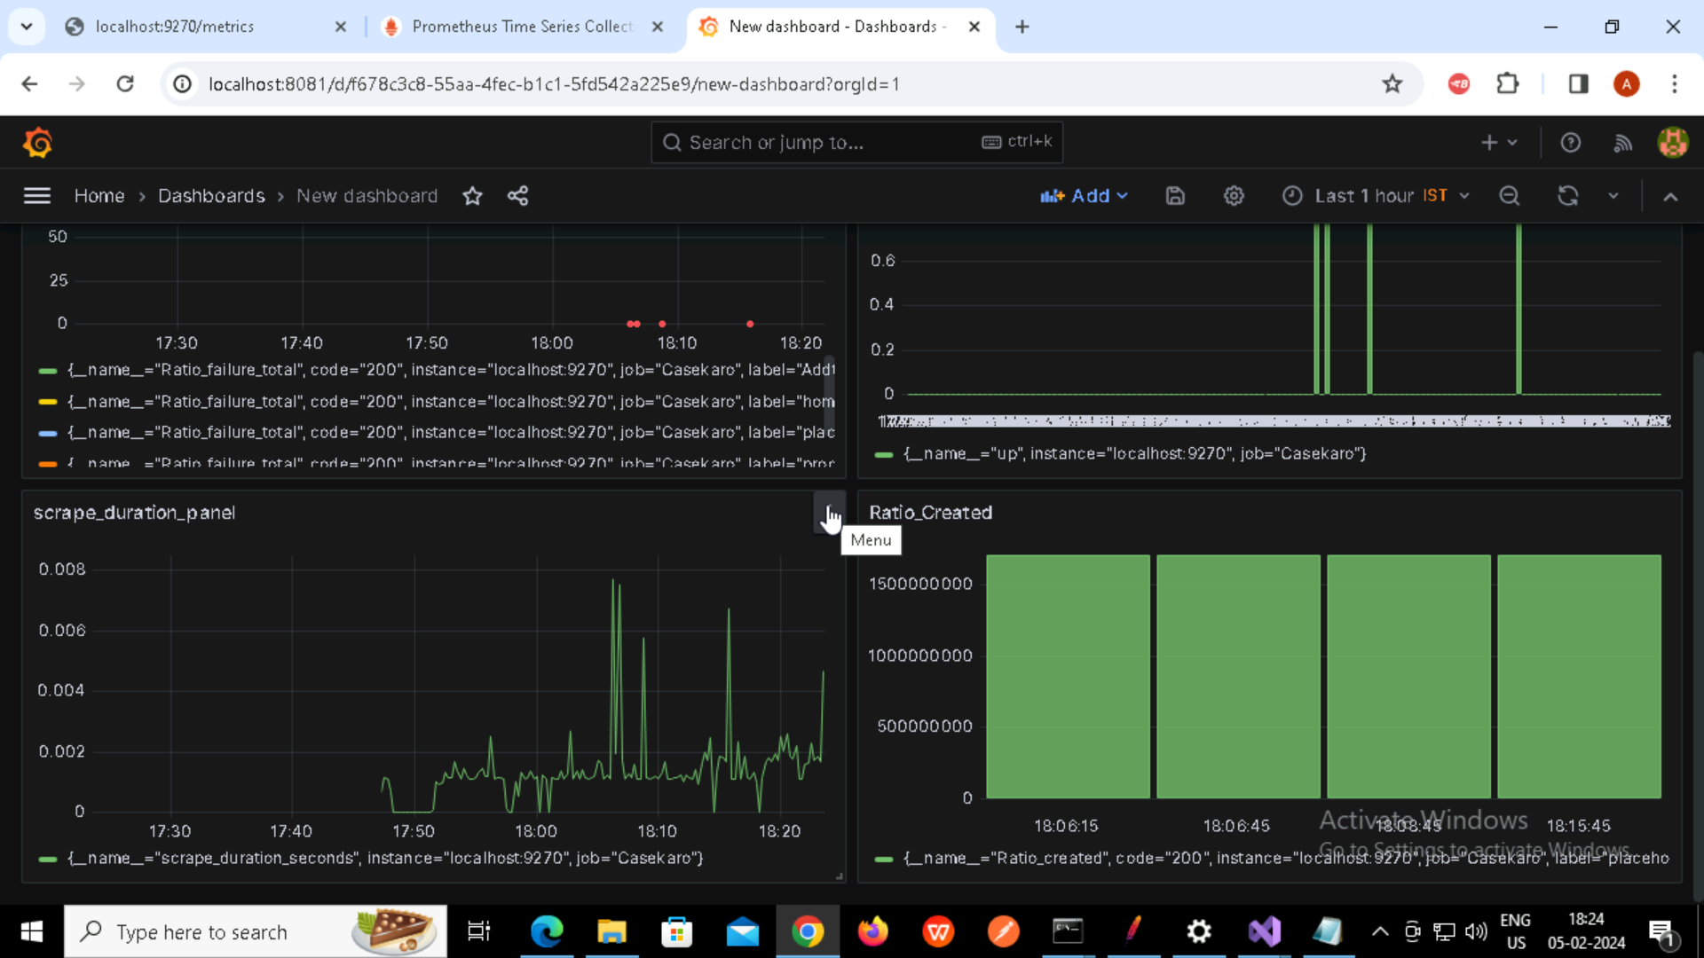

Running jmeter tests in non GUI mode and generating logs and reports in specified destinations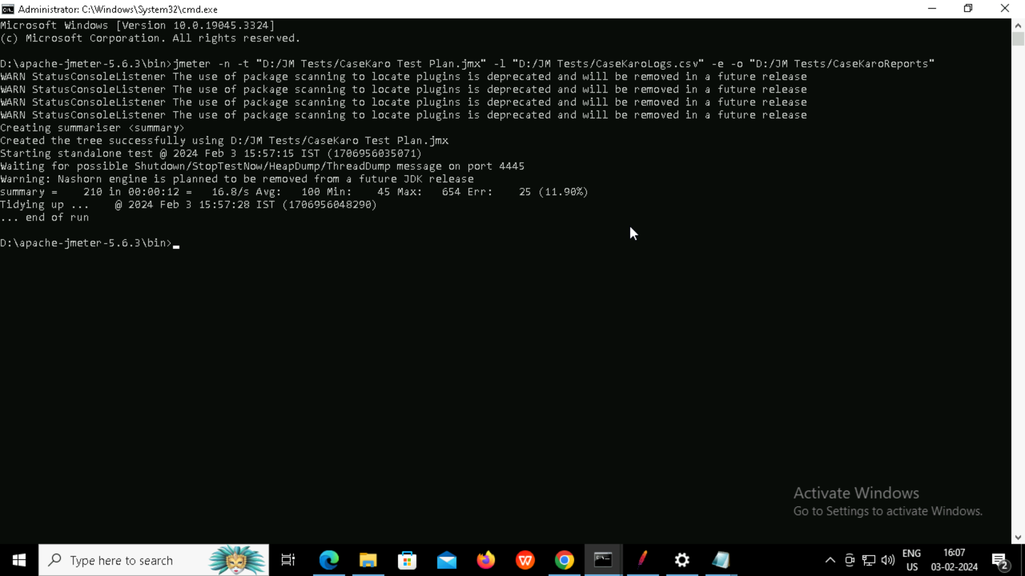

Report Index file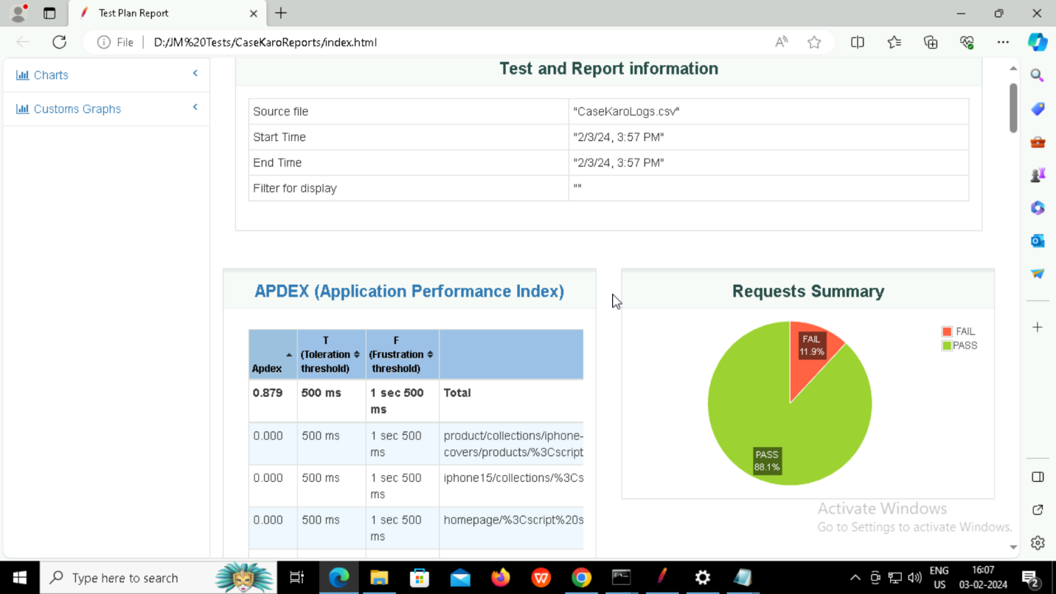

**Log file as csv**